**Implementation Module -**

1. Methods used:

After going through the disadvantages and the advantages of all the methods for detecting an eye blink to trigger an event, we choose the Infrared method of detecting the eye blink because of its advantages that far outweigh its disadvantages.

The advantages of using IR for blink detection are as follows –

1. It is very user friendly and cost effective compared to other methods.
2. The final product looks very simple and nor complicated for users. Also, it is light weight.
3. This method gives greater accuracy than any other method used for blink detection.
4. It does not involve large hardware components which make the product heavier.
5. Adding to this, the method or hardware technology used to detect the eye blink should be able to pass a signal to the microcontroller easily and relinquish its control to another component, which can be easily implemented in this case.

Hence, based on these advantages, the Infrared and microcontroller based eye blink detection system seemed to be more feasible and reliable and hence, we choose this method to detect the user’s eye blink.

There are some problems of using this technology as well. One of the problems, which we will face while implementing this method is to differentiate between voluntary and involuntary blinks. We successfully found out a way to differentiate between these different types of blinks so that the event is not triggered whenever the user blinks involuntarily or in simpler words, because of natural blinks. But this can be easily solved by setting a condition that if the user blinks twice in the time range of 2 seconds, the event will be triggered. Another condition which we can use is if the user blinks a single eye and does not blink the other one, the event will be triggered. Any of these conditions can be set and implemented.

This will make the entire process more effective and less complicated, so that any user can understand the process.

1. Working of the project:

Let us understand the entire process by referring to a block diagram –

Eye blink detection using Infrared tech

Microcontroller

Camera

Bluetooth module

Image transferred to Smartphone

Here, we can clearly understand the entire process of this application. The function and workflow of each component is given below:

Eye blink detection using Infrared and Microcontroller:

The Infrared emitter and detector are on continuously after the device is switched on by the user. The data received by the Infrared receiver is continuously supplied to the microcontroller for example Arduino. The microcontroller looks for ‘OFF’ signals among the signal inputs provided to it. These OFF signals are transmitted when the Infrared ray is obstructed and the detector does not detect any Infrared ray. When the microcontroller detects this OFF signal it starts looking for an ON signal and an ONFF signal following it under a time interval of 2 seconds. If all the conditions pass, the microcontroller triggers the event and it sends a signal to the camera to capture an image and relinquishes the control to it.

Camera –

When the microcontroller sends a signal to the camera, the camera captures an image using its module and makes this image ready for transferring it to the smartphone via Bluetooth. The camera module is connected to the microcontroller such as Arduino to automatically control the camera. The microcontroller is connected to the camera via a diode and a shutter switch cable. When the microcontroller passes a LOW voltage signal to the camera, the camera module activates and when the microcontroller passes a HIGH voltage signal to the camera, the diode becomes reverse biased and prevents the electricity flowing into the camera to avoid damaging thee camera module. In this way, a microcontroller and a camera work. The camera which is suited for this use is the LinkSprite JPEG Colour Camera TTL Interface, which looks like this –

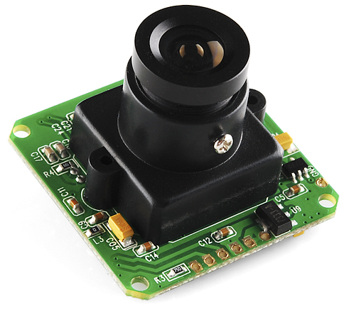

Bluetooth module –

Bluetooth is a wireless technology which helps in transferring files from one device to other using radio waves. It operates at the frequency of around 2.4 GHz. The transfer of data takes places only over short distances. After the camera has captured the image it transfers the image to the Bluetooth module and makes it ready to transfer. The microcontroller then transfers the control to the Bluetooth module. The Bluetooth module has to be paired with the smartphone for transferring the images without any glitch. It then transfers the image wirelessly to the android device. The Bluetooth needs to be connected to the camera and the microcontroller at the same time. The Bluetooth module when connected to the Arduino board, in this case, looks as –

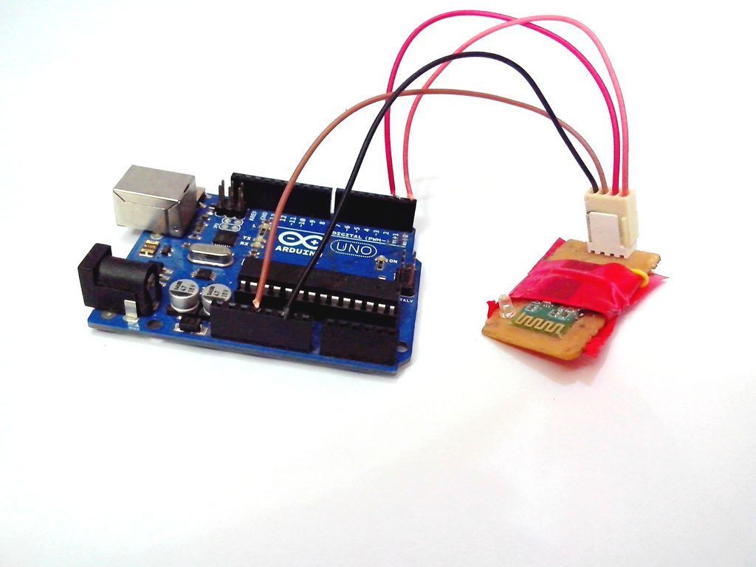

In this way, these components function to give optimum results for the application. This application will help the disabled and paralyzed people to be able to gain the joys of life. They will be able to capture the world through a camera without restraining due to any of their disability.